GARDEN TABLE FEEDERS
CATEGORY | DESCRIPTION | APPEARANCE | SIZE
Small Garden Birds | A wide variety of birds such as Sparrows, Finches, Tits and Robins. This is the category that most bird table owners wanting to look after, and in many cases have declining populations. | 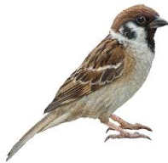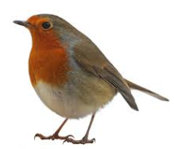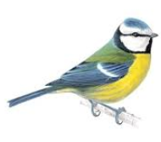 | Range 10-30 grams  - Blue Tit: 9-12 g  - Robin: 16-22 g  - Sparrow: 20-28 g  - Chaffinch: 18-30 g
Medium sized Garden Birds | A small variety of birds such as Blackbirds, Thrushes and Starlings. These are also welcome visitors to the bird table. | 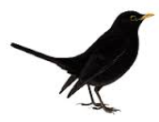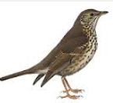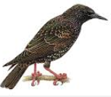 | Range 80-125 grams  - Blackbird: 80-125 g  - Thrush: 70-90 g  - Starling: 75-90 g
Large Garden Birds | A wide variety of birds such as Crows, Rooks, Magpies and Jays. These birds do not generally compete for the same food sources as smaller birds but will take food from tables. They also take small bird eggs and chicks and therefore need to be treated as unwanted visitors. | 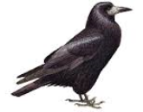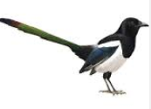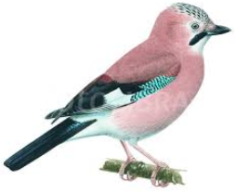 | Range 150-300 grams  - Crow: 200-300 g  - Magpie: 200-220 g  - Jay: 150-190 g
Wood Pigeons | Very common in gardens across the UK. With populations growing, pigeons increasingly compete with smaller garden birds. Pigeons are unwanted visitors | 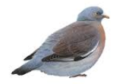 | 450-550 grams
Grey Squirrels | Also common in gardens across the UK. With populations growing, grey squirrels compete with smaller garden birds as well. Squirrels are unwanted visitors. | 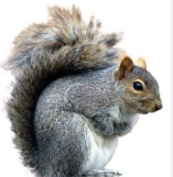 | 400-600 grams

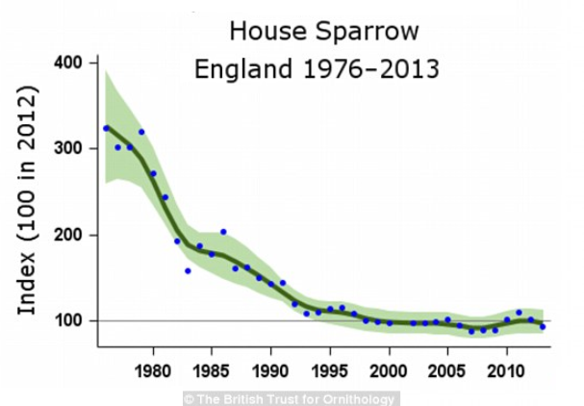
GARDEN BIRD POPULATIONS & PROTECTION
In recent years the population of small garden birds has fallen significantly. This can be seen in the upper graph across showing the change in the house sparrow population in England over the last 40 years. It can be seen that the population has fallen by approximately 60%. This fall is also true for many other common garden birds. The RSPB (Royal Society for the Protection of Birds) have published the following declines for the period 1970-2000:
- Tree sparrow - 95%
- Starling - 71%
- Song thrush - 56%
- Bullfinch - 53%
The centre and lower graphs show that the opposite is true for other animals that compete for food with small garden birds. During the same period the population of pigeons increased by approximately 300% and grey squirrels by approximately 50%. Whilst it has not been proven that these changes are related the RSPB have stated that “They (pigeons) are large and dominant, so many other birds may prefer to keep out of their way rather than compete with them for food”
The RSPB also talks about the importance of the availability of food during certain times of the year “Cold winters can kill a lot of birds through starvation. The smaller the bird, the more likely it is to be affected by prolonged winter cold. Robins, wrens and blue tits can be affected by cold snaps” and “Food availability in May and June can be crucial in deciding how many chicks survive to fledge”.
The importance of ensuring that food put out in the garden is eaten only by small birds can be seen. Whilst commercially available bird tables can be quite effective at keeping squirrels away from the food, they cannot do the same for pigeons etc.
The RSPB also emphasize the importance of monitoring the population trends of many species of birds. In the case of small garden birds, this can only be done by the public. The RSPB “Big Garden Bird Watch” occurs every January and involves member of the public recording the numbers and types of birds visiting their gardens in a day

